### Semester One Examination, 2018



### Question/Answer booklet

# Year 11

# MATHEMATICS METHODS

## Section Two:

## Calculator Allowed

**Booklet 3 of 3**

Student name

|  |  |  |  |  |  |
| --- | --- | --- | --- | --- | --- |
| **IFB** | **DD** | **VMU** | **SWA** | **MS** | **AGC** |

**Circle your teacher’s Initials:**

## Time allowed for this section

Reading time before commencing work: ten minutes

Working time: one hundred minutes

## Materials required/recommended for this section

***To be provided by the supervisor***

Two Question/Answer booklets – complete both.

Formula sheet (retained from Section One)

***To be provided by the candidate***

Standard items: pens (blue/black preferred), pencils (including coloured), sharpener,  
correction fluid/tape, eraser, ruler, highlighters

Special items: drawing instruments, templates, notes on two unfolded sheets of A4 paper, and up to three calculators approved for use in this examination

## Important note to candidates

No other items may be taken into the examination room. It is **your** responsibility to ensure that you do not have any unauthorised material. If you have any unauthorised material with you, hand it to the supervisor **before** reading any further.

Question 16 (4 marks)

The set of values in the table follow the rule 

|  |  |  |  |
| --- | --- | --- | --- |
| *x* | 2 | 4 | 7 |
| *y* | 14 400 | 20 736 | 35 831.808 |

(a) Determine the rule. (3 marks)

(b) Calculate the value of *y* when *x* = 20 (1 marks)

Question 17 (6 marks)

A hiker has gone missing in a National Park. The ranger provides details of the search area.

The information is represented in the diagram below.

3 km

20º

Car Park

7 km

Creek Junction

1. Calculate the size of the search area. (5 marks)
2. Is there anything wrong with the information supplied by the park ranger? (1 mark)

Question 18 (3 marks)

A financial planner predicts your investment will grow at an increasing rate over time according to the rule:



Where  is the amount of your investment at the end of *t* years and is the amount of your initial investment.

According to this rule, what is the least number of years it will take for your investment to triple in value?

Question 19 (6 marks)

(a) Part of the graph of $y=f(x)$ is shown below, where $f\left(x\right)=-2{\left(x-b\right)}^{3}+c$, and $b$ and $c$ are constants.

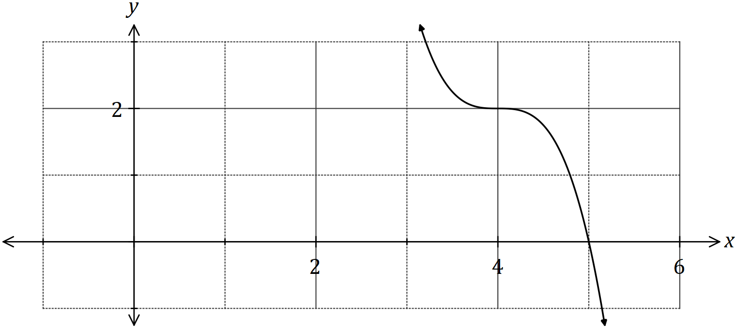

(i) State the degree of $f(x)$. (1 mark)

(ii) Determine the value of $b$. (1 mark)

(iii) Determine $f(0)$. (2 marks)

(b) Another function is given by $g\left(x\right)=f(x+8)$.

Describe how to obtain the graph of $y=g(x)$ from the graph of $y=f(x)$. (2 marks)

Question 20 (11 marks)

During 2018, the altitude of the sun,  degrees, at noon in Melbourne on the $n^{th}$ day of the year can be modelled by the equation



(a) On the 26th of January, the altitude of the sun was $71.4°$.

Calculate the altitude ten days earlier.

(2 marks)

(b) Graph the altitude on the axes below for $0≤n≤365$. (4 marks)

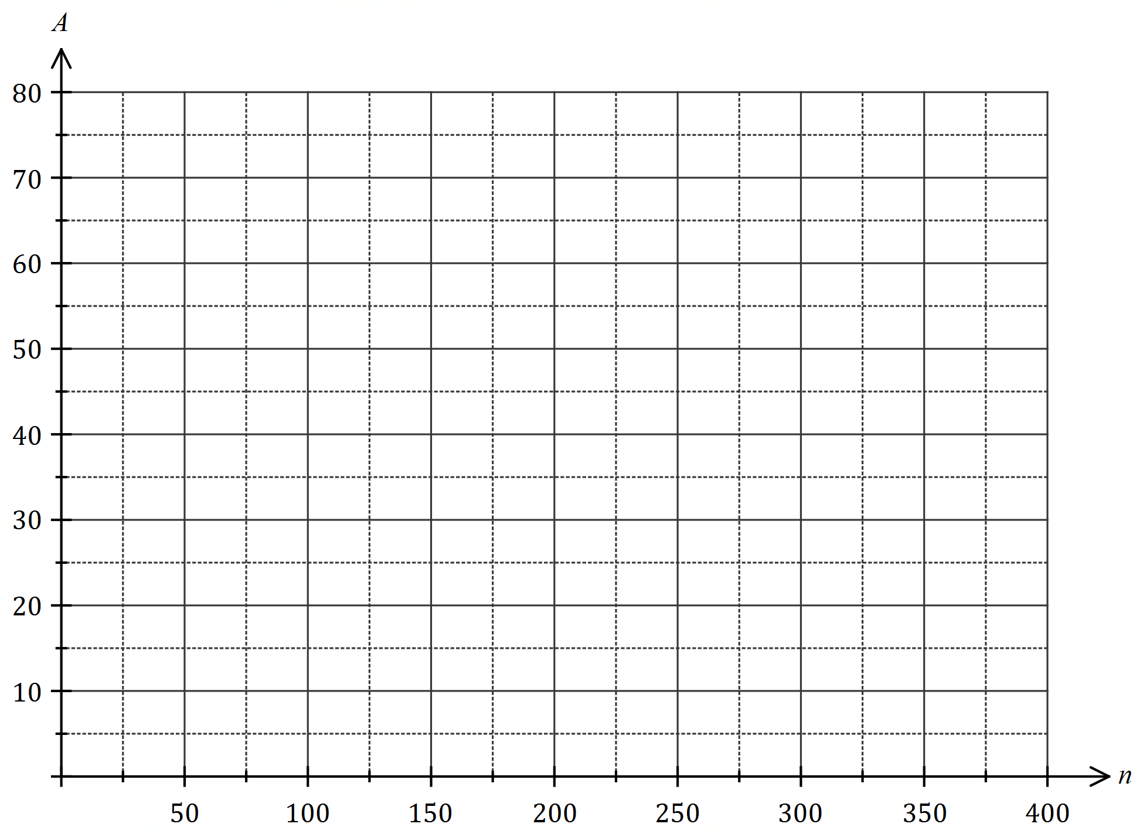

(c) State the minimum altitude of the sun at noon in Melbourne and on which day of the year this occurred. (2 marks)

Solar panels on the roof of a Melbourne business are designed to meet its entire power needs on cloudless days when the altitude of the sun is at least $36°$ at noon.

(d) Determine the number of days the panels are expected to achieve this aim during 2018, ignoring the possibility of cloud cover. (3 marks)

Question 21 (5 marks)

Consider the points with coordinates  and  that lie in the first and second quadrants respectively of the unit circles shown below.

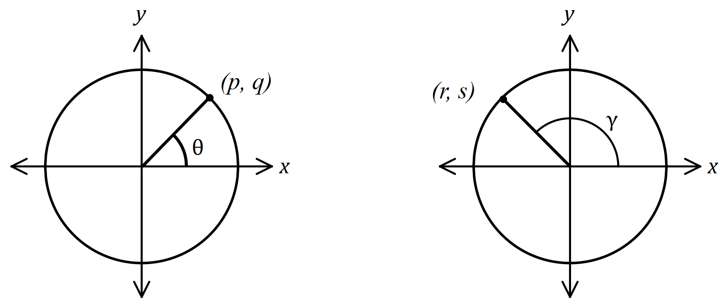

Determine the following in terms of  and , simplifying your answers where possible.

(a) θ (1 mark)

(b)  (1 mark)

(c) 

. (1 mark)

(d)  (2 marks)

Question 22 (7 marks)

Calculate the area of the shaded region enclosed by two circles of radius 15cm and 8cm and the line, as shown in the diagram below.

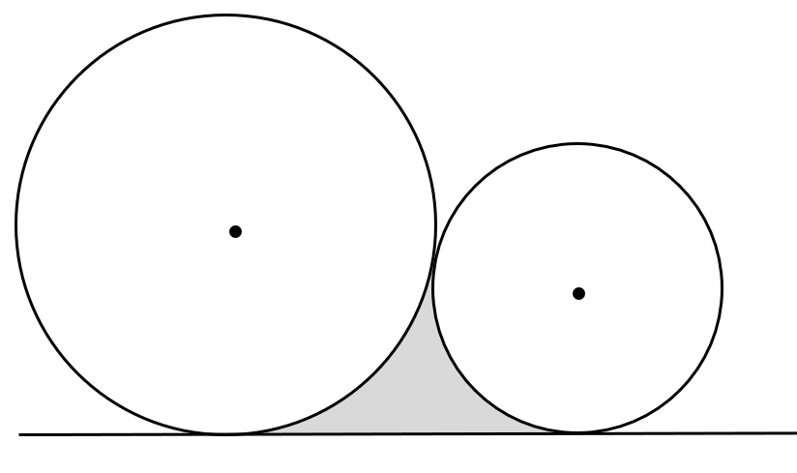

Supplementary page

Question number: _________

Supplementary page

Question number: _________